The Independent Insurance Agents

of Monmouth & Ocean Counties

Annual Golf Outing at the

Pine Barrens Golf Club

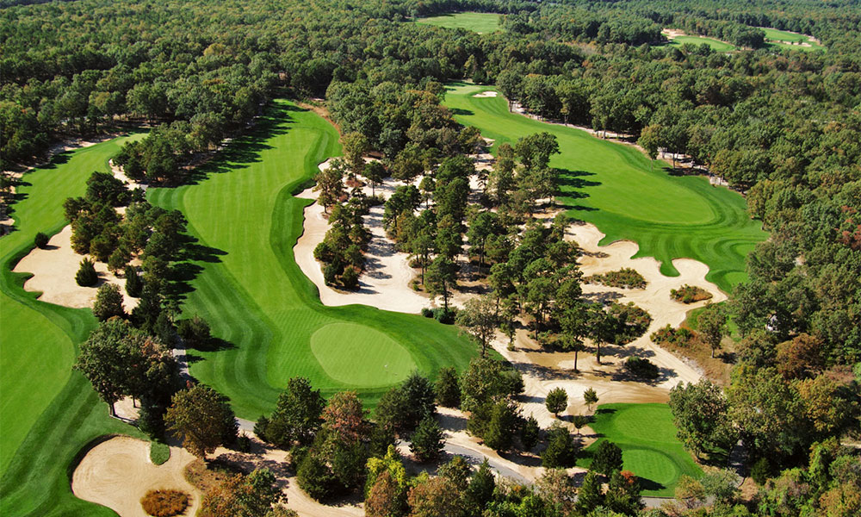

540 So. Hope Chapel Rd., Jackson, NJ 08527 732-408-1154

When: Monday, October 2nd, 2023
Time: 8:30-10:00am Registration & Breakfast
10:00am Shotgun Tee Off
2:30pm Cocktails & Lunch to follow

Full Golf Package/Golfer $225 Lunch Only $25

Raffle and award prizes announced during lunch
Golf Shirt Men S to 3XL ___ Golf Shirt Women S to 2XL ___
Please Reply by August 26th

(Circle One)
Hole Sponsorship $150 Golf Cart $250

Longest Drive $200 $10,000 Hole In One Sponsorship $350
Closest to Pin $200 Cocktail Hour Sponsorship $500 Breakfast Sponsorship $250 Lunch Sponsorship $500

Beverage Cart $250

Sponsorship:_________________________________________________

Golfer’s Name:
1____________________________________________
2____________________________________________
3____________________________________________
4____________________________________________

Place me/us in a foursome________

Pay by Credit Card (Visa, MasterCard or Amex) Total Paid_____________________
Card No. ____________________________________ Exp date: ____/_______ (mm/yyyy)

Name on Card__________________________CVV2code_______Signature________________________
Billing address and phone #:______________________________________________________________
Please make your checks payable to: IIAMOC and mail to:

Mario DeFilippis, Wharton Atlantic, 615 Hope Road, Bldg 2B, Tinton Falls, NJ 07724
Questions? Please call Mario at 732-686-7020, Fax 732-531-4698
Register Early, Space is Limited to the first 100 Paid Golfers

